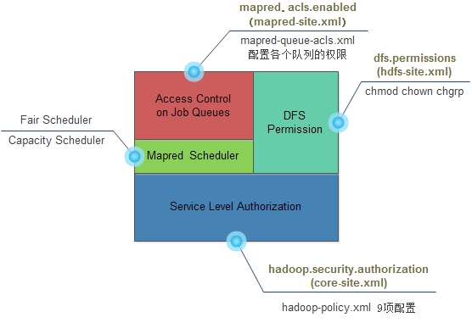

http://hadoop.apache.org/docs/current/hadoop-project-dist/hadoop-common/ServiceLevelAuth.html

Service Level Authorization 系统级，用于控制是否可以访问指定的服务

hadoop.security.authorization=true

则开启ServiceLevel Authorization，若为false则不经过任何验证，所有用户拥有全部权限。(修改此配置需要重启hadoop)

服务层授权：

https://www.iteblog.com/archives/983.html

https://www.cnblogs.com/lzfhope/archive/2017/06/21/7058906.html

https://www.cnblogs.com/hanxiaohui/p/8526997.html